

**Boston University**

**Electrical & Computer Engineering**

**EC463 Capstone Senior Design Project**

**Problem Definition and Requirements Review**

**The Art of Valuation**

Submitted to

Workshop Finance

brendan@workshopfinance.com

by

Team 30

DevUp

Team Members

Prithika Ganesh pvganesh@bu.edu

Ignacio Nunez Gomez inunezg@bu.edu

Suyash Bhatia suyashb@bu.edu

Zen Mae Lee leezm@bu.edu

Submitted: October 14th, 2022

**Customer Sign-Off _______________________________________**

**The Art of Valuation**

**Table of Contents**

| **Section** | **Content** | **Page** |
| --- | --- | --- |
| 1 | Need for this Project | 2 |
| 2 | Problem Statement and Deliverables | 3 |
| 3 | Visualization | 4 |
| 4 | Competing Technologies | 6 |
| 5 | Engineering Requirements | 7 |
| 6 | References | 9 |

**Project Summary**

Workshop Finance is a deal idea generation tool, allowing users to quickly build valuations. The application provides a recommendation engine leveraging a broad set of third-party fundamental data to identify the best levers (e.g. similar companies, trading multiples, time periods) for a given company. Workshop then performs the necessary calculations and presents results through a visualization called a football field, a graphic which typically appears in investment banking pitch books. The mobile application allows users to view, refine, and share this football field directly through the app. Workshop will enable deal idea generation, client communication (i.e. pitching to clients, initializing cases), and deal execution. Workshop Finance will become the primary medium through which users “tell the story” of a company’s valuation—the key point in any corporate finance discussion. This first-of-its-kind application will power the ***art of valuation*** through a combination of strict corporate finance theory and innovative user experience.

**1. Need for this Project**

Every company, whether a small private startup or an industry giant, possesses a numerical value. Investors, bankers, brokers, and financiers alike spend their life’s work creating models and valuations for companies, trying to quantify what exactly a company is worth. This piques the particular interest of the financial market’s mergers and acquisition sector, where companies are being sold to or incorporated into larger organizations. Here, in a marketplace where over $5.9 trillion in deals were done in 2021 alone, finding the true value of a company is critical.

Fortunately, industry experts deploy various mathematical models, industry comparisons, and research to try arriving at the true valuation of an organization, often displayed in a side-by-side comparison known as a “Football Field” representation. Unfortunately, this level of research and comparison is incredibly labor and time intensive, involving junior employees feverishly clamoring away on Excel sheets and files, only to discover that the valuation they were working on was fruitless and an overall ill-advised idea for a merger. This wastes company time, money and resources, which could be put towards more fruitful endeavors. In today’s fast-paced world, where data, numbers, and valuations can change overnight, companies cannot afford to lose this time.

Workshop Finance aims to mitigate this waste of precious time and resources by providing initial valuations at the consumer’s fingertips. By rapidly calculating and delivering comparable valuations in a football field representation within minutes, those working within these financial sectors can have baseline metrics at their fingertips, empowering them to make better-informed business decisions—like which comparisons and deals are worth investing more resources on. At the same time, Workshop Finance helps modernize the antiquated methodology of today’s financial systems—better adapting to the technologically advanced world where individuals have become accustomed to receiving answers instantly from a tap on their phone. By bringing more knowledgeable comparisons and valuations to the greater market, Workshop Finance not only modernizes the financial valuation space, but also democratizes financial knowledge to the greater public.

**2. Problem Statement and Deliverables**

While there are already tools and methods to value companies using the “football field” chart (Fig 2.3), none of them are fast, dynamic, and responsive. Such tools rarely evaluate both private and public companies, yet financial corporations typically require valuations of both. Therefore, the core of this project is to create a fast and intuitive mobile application for corporate finance valuation. The application will be able generate user-tailored models based on public and private companies. This application will be the first of its kind, determining how much a company is worth today, at some point in the past, and the projected future.

Within the application, the user will select the target company to value. If the company is public, the app will automatically fetch its public financial data from an API, using CRM integration (Fig 2.1). This API will provide the app with all of the public market data needed to precisely calculate valuations. If the user decides to value a private company, the user will need to manually input its fundamental financial data (Figs 2.2-2.3).

Once the desired company to value is chosen, the app instantaneously produces valuation models through both relative and intrinsic value methodology. It is a priority that the valuation is dynamic and fast. The company’s valuation will be portrayed as a “football field” chart (Fig 2.3). The user will then be able to adjust the company’s value calculations and visual output by adjusting financial variables, such as by adding several companies from the specific industry to create a financial comparison (COMP) or by editing the index’s multiplier. This visualization will have live updates, and the user will be able to share it in social media platforms, send it via email, or export and save it as a JPEG document.

To improve the application’s user experience, a recommendation feature will be implemented wherein suggested companies to value are shown as the user is creating a new valuation. The machine learning method of clustering will be able to utilize the user’s search and input history to suggest similar companies to value. For example, the data used will be the public companies which the user has searched, and the manually inputted financial data of private companies. Classifying clusters will be determined by the company characteristics (industry, age, etc) and financial data. Based on these comparison points, the application will be able suggest companies that align with the user’s preferences and cultivate a personalized experience.

It has to be said that it is a priority for the application to be responsive and dynamic. This means that, if a chart is created and the user decides to make a change in the financial variables that are being displayed, the application will quickly refresh the chart with the new set of variables and calculations. The application must allow for rapid additions and deletions of valuation measures.

**3. Visualization**

The primary problem this app is trying to solve is the rapid generation of valuation models for both private and public companies alike. Therefore, the app needs to work with two tandem models, an automatically generated base-stats for public company valuations, and a user-input generated customizable model.

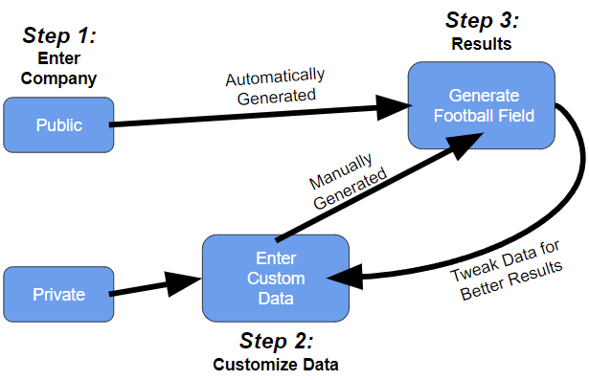

*Figure 1.1: Flowchart depicting the required workflow for the generation model of both public and private company models. When a public company’s name is entered, the app can bypass the intensive manual user-data entry, and simply have a basic Football Field evaluation created by the app’s smart interface. The user then has the option to tweak this football field and edit the comparisons being shown and add more data. For private companies, the user is required to add more intensive data from the start, as this data is not public knowledge.*

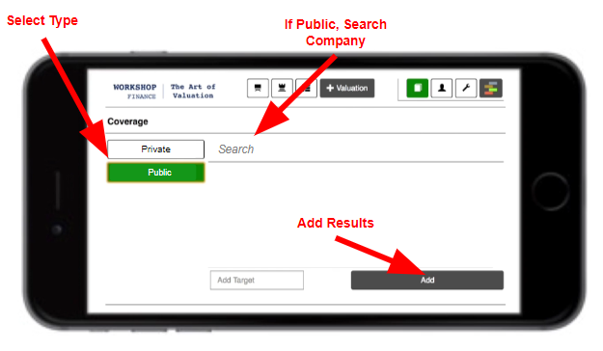

*Figure 2.1: Basic interface idea, selecting private vs public company valuation.*

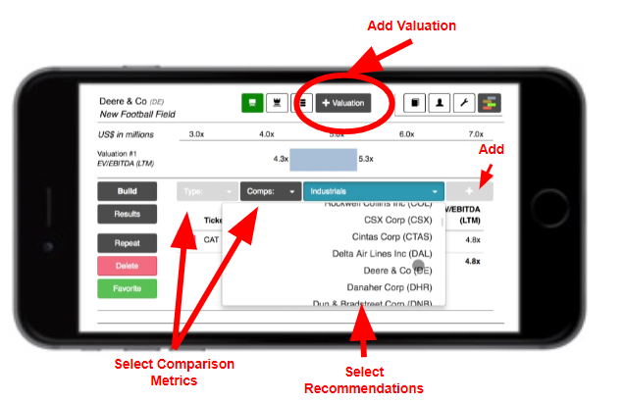

*Figure 2.2: The client wants easily customizable devices and metrics for the end-user, allowing high powered individuals to rapidly and effectively create Valuations. This figure displays possible valuation customization options within the app.*

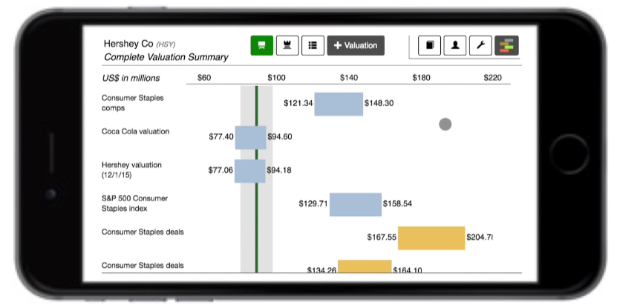

*Figure 2.3: Resulting Football Field Valuation. Easy to read. Note the landscape mobile view, as the client envisions.*

**4. Competing Technologies**

There are several financial softwares and services available for users to access data and competitively refine their market knowledge. The most significant, powerful tools as advised by the client are Excel, Refinitiv (previously Thomson Reuters), CapitalIQ, and FactSet.

*4.1 Excel*

A powerful computing tool commonly used by most financial corporations to handle massive quantities of data by applying a large range of computations and has the ability to produce visuals generated from this data, such as pie charts and line graphs. Although this technology is junior-level compared to the other enlisted competing technologies, companies continue to use Excel because of convenience and technological inertia [1].

*4.2 Refinitiv*

Refinitiv is a London Stock Exchange Group (LSEG) business among the world’s largest providers of financial market infrastructure and data. The company provides information, insights, and technology which enables customers across 190 countries to confidently execute investing, risk decisions and trading by orchestrating an open platform and best-in-class data and expertise [2].

*4.3 S&P Capital IQ*

The firm investigates financial news, company performance and sector-specific data, and market insights to millions of private firms and 60,000+ public companies on a subscription basis. Capital IQ employs a widespread approach to market analysis that caters to large-scale traders to financial hobbyists. A flagship service, Compustat, allows users to access real-time market data from the Compustat database which can be formatted using customized tools [3].

*4.4 FactSet*

FactSet was awarded Best Market Data by Asian Private Banker Technology Awards 2020 and currently assists over 7000 financial services firms globally. Users are able to access real-time, delayed, and historical market data from major sources worldwide including 40 proprietary datasets and over 850 sets from independent providers. With a comprehensive range of analytical and trading solutions and open platform and services, users are able to take action on their portfolios and overcome workflow challenges by subscribing to FactSet [4].

**5. Engineering Requirements**

This section contains an in-depth description of the objectives, functions, and constraints pertaining to the mobile application’s front and back end components. The front end includes user experience, user interface, and local data storage. The back end includes computation engine, API integration, identity service, database, recommendation engine, and cloud-based hosting.

| *Feature* | *Objectives* | *Functions* | *Constraints* |
| --- | --- | --- | --- |
| User Experience | For the app to run smoothly and reliably produce visuals and results. | Efficiently generate view of valuations with quick data fetching facilitated by an optimized backend. Ideal page load time of <3 seconds [5]. | Team’s limited knowledge on UX development. |
| User Interface | Enable users to control the application and view the football field graphics. | Include basic navigation features and a holistic range of levers for the user to customize their valuations; functional scope of application to have ~70 elements e.g. “Add New Valuation” and “Change Target”. | Team’s limited knowledge on UI development. |
| Local Data Storage | To preserve user search and valuation history to be retrieved when the user returns to application after use. | Store user data locally on the device to provide users with an instant startup experience. Productivity apps on iOS typically take up about ~400MB of space e.g. Excel [6]. | Limited to device storage application is operating on. |
| Computation Engine | Reduce workload on the frontend to reduce storage load on the device. | Define the frontend payload to perform actions such as users changing their valuation criteria. | Running several calculations can be computationally intensive. |
| API Integration | To minimize use of local storage and allow users to efficiently access a wide range of updated market data for valuations. | Implement API optimization techniques such as caching and ensuring sufficient cloud infrastructure. | Limited by the abilities of the API used and the amount of cloud storage available. |
| Identity Service | To have safe, synchronous multi-user access for customers. | Authenticate user profiles for each user logging into the application and keep user information confidential. | Team’s limited knowledge on cybersecurity; may encounter data leaks. |
| Market Database | To reliably and efficiently fetch data from the market database (i.e. based on the date the user chooses). | Employ a range of third-party databases to be accessed through APIs with a daily refresh rate. | Limited by financial resources and the magnitude of data needed. |
| Recommendation Engine* | To provide a personalized user experience and buffer as a user searches for a company to value. | Using machine learning models such as clustering on a range of user inputs over time. | Limited by the capabilities of the ML model chosen to deploy. |
| Cloud-based Hosting | Scalable access to computing resources for the functioning of the application. | Employing advanced, reliable cloud services such as IEX. | Limited by financial resources. |

*Figure 3.1: Table detailing the application’s objectives, functions, and constraints. Note: the ‘*’ indicates a stretch goal feature.*

**6. References**

Bibliography

[1] “Microsoft Excel Spreadsheet Software: Microsoft 365,” *Spreadsheet Software | Microsoft 365*. [Online]. Available: https://www.microsoft.com/en-us/microsoft-365/excel.

[2] “Financial Technology, Data, and Expertise,” *Refinitiv*. [Online]. Available: https://www.refinitiv.com/en?utm_content=Refinitiv Brand Core-US-AMER-G-EN-Exact&utm_medium=cpc&utm_source=google&utm_campaign=596234_PaidSearchBrandKeywords&elqCampaignId=16988&utm_term=refinitiv&gclid=Cj0KCQjwhY-aBhCUARIsALNIC0727CAmPB-gpGaO9Qxw_csss1Plar48NS9hoZdMfqPmsh_GGxSOraoaAmzaEALw_wcB&gclsrc=aw.ds.

[3] *FactSet*. [Online]. Available: https://www.factset.com/.

[4] “S&P Global Market Intelligence,” *Home | S&P Global Market Intelligence*. [Online]. Available: https://www.spglobal.com/marketintelligence/en/#request-demo.

[5] AppMySite, “Reduce app load time and increase speed - Your ultimate guide to a better UX,” *AppMySite*, 14-Jul-2022. [Online]. Available: https://www.appmysite.com/blog/reduce-app-load-time-and-increase-speed-your-ultimate-guide-to-a-better-ux/.

[6] D. Nations, “How Much iPad Storage Do You Need?,” *Lifewire*, 31-Dec-2021. [Online]. Available: https://www.lifewire.com/how-much-ipad-storage-needed-1994385.

“Microsoft Excel Spreadsheet Software: Microsoft 365.” *Spreadsheet Software | Microsoft 365*, [www.microsoft.com/en-us/microsoft-365/excel](http://www.microsoft.com/en-us/microsoft-365/excel).

*Refinitiv*, https://www.refinitiv.com/en?utm_content=Refinitiv.

*FactSet*, www.factset.com/.

“S&P Global Market Intelligence.” *Home | S&P Global Market Intelligence*, [www.spglobal.com/marketintelligence/en/#request-demo](http://www.spglobal.com/marketintelligence/en/#request-demo).

AppMySite. “Reduce App Load Time and Increase Speed - Your Ultimate Guide to a Better UX.” *AppMySite*, 14 July 2022, [www.appmysite.com/blog/reduce-app-load-time-and-increase-speed-your-ultimate-guide-to-a-better-ux/](http://www.appmysite.com/blog/reduce-app-load-time-and-increase-speed-your-ultimate-guide-to-a-better-ux/).

Nations, Daniel. “How Much IPad Storage Do You Need?” *Lifewire*, Lifewire, 31 Dec. 2021, [www.lifewire.com/how-much-ipad-storage-needed-1994385](http://www.lifewire.com/how-much-ipad-storage-needed-1994385).